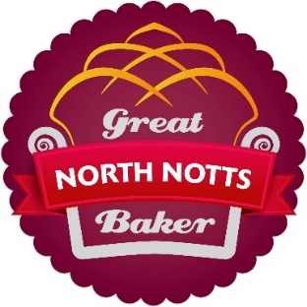

Are you the Great North Notts Baker?
Free to enter baking competitions at North Notts Food Fest – Thursday 25th July 2019
Simply bring along your entry which you feel celebrates ‘summertime specials’.
Maybe that’s a day at the beach, ice-cream, sunshine or a picnic – it’s up to you!
Entries accepted between 10-11am on the day to be delivered to the competition market stall on the old market square, Worksop.
Entries to be judged on taste and appearance by independent judges.
Classes are:
* Open (13yrs and over – no professional bakers please!)
* 12yrs and under
Make your favourite animal out of fruit or veg and entre our children’s competition:
Younger children (6yrs and under) can also take part in the make your own animal from fruit and vegetables. Entries for this are also to be dropped off at the competition market stall. Cocktail sticks or similar are permitted to aid construction in this class.
Entries can be collected at the end of the day at 5pm. Any entry not collected by this time will be disposed of.
--------------------------------------------------------------------------------------------------------------------------
Simply complete your details below and bring this form along with your entry.
Full Name:
Class Entered:
Age: Signed:
(by parent/guardian if under 18)
Contact telephone number:
(We will contact you on the day after judging if you have won your class and we would be grateful if you could attend a photo-call and prize giving at 2.45pm)
Email address:
(Please note we will only contact you again in relation to any other activities run by NNBID which we think you may be interested in. You will be able to opt out at any time)

