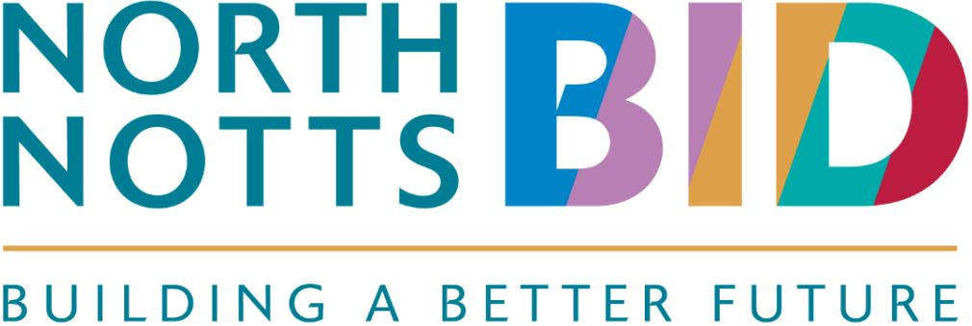

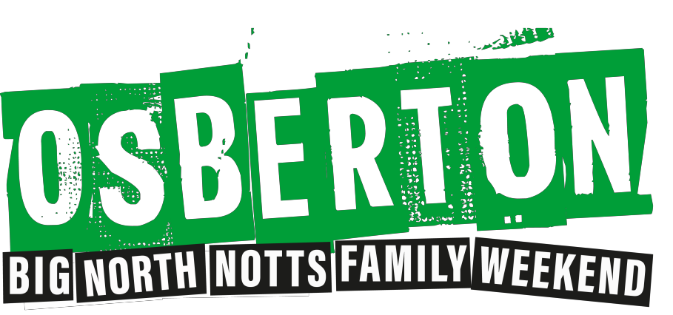

North Notts BID is pleased to announce an exciting partnership with Osberton International Horse Trials.
Bede Events, organisers of the Osberton horse trials, are offering every BID Member business and its employees the opportunity to access FREE family tickets to the event over the weekend of Saturday 5th and Sunday 6th October 2019.

Each year the horse trials welcomes over 5,000 visitors to the estate over the four days. Many of the World’s top athletes compete at Osberton, bringing their future stars to compete in the Championship classes. It is the ideal chance to rub shoulders with Olympic and World champions and see them at close quarters.

This year Osberton will also host carriage driving for the first time with top drivers pitting their prowess as they drive at speed through the winding obstacles.

As well as the equestrian activities, Osberton offers a wealth of fun for all the family including a shopping village offering a wide variety of outlets, bars and eateries. These include a popular street food and a Gin Den. There is also a children’s fun fair and you can have a go at dog agility! The shopping village ensures that there is something for all.
Stuart Buntine from Bede Events said: “BEDE Events is delighted to be working with the North Notts BID to raise the region’s profile and drive tourism to the area. The event annually contributes over £2.5 M to the local economy. We are looking forward to building a stronger relationship with the region’s businesses.”
To take advantage of this offer please apply for your FREE family ticket code by contacting Georgie at the BEDE Events office - georgie@bedeltd.co.uk.

Important Information:

- BEDE Events will issue you with your own ticket code to share with your employees for them to purchase a family pass for either the Saturday 5th or Sunday 6th October.
- Tickets can then be booked via the event ticket office.
- A small car parking charge will apply.
- Posters and flyers will be available to you, so you can circulate the event to your employees

